|  |  |
| --- | --- |
|  | AMERICAN INTERNATIONAL UNIVERSITY-BANGLADESH (AIUB)  Department of Computer Science & Engineering  Faculty of Science & Technology  Undergraduate Program |



**Blood Bank Management System**

**Introduction:**

Blood banks play an important role in the process of collecting blood and managing blood stocks, approving blood requests, updating donations and updating available blood types. As blood is related to someone’s life so blood management system must be handled with care and treated thoroughly. The process of managing the blood needs a proper and systematic management. For that reason, blood bank management system is important for managing blood. Blood bank management system is an online software system that helps in managing various blood banks in a better way. This project provides details about the various blood deposits that are available. These specifics include blood type, storage location, and storage date. These details help in maintaining and monitoring the blood deposits. The project is an online system that allows to check whether required blood deposits of a particular group are available in the blood bank. Moreover, the system also has added features such as patient name and contacts, blood booking and even need for certain blood group is posted on the website to find available donors for a blood emergency.

**Objectives:**

1. Ensures hospitals have good supply or inventories of blood bags.
2. List the availability of blood bags at any given time.
3. To create an efficient system for the donors.
4. Ability to manage the information of its blood donor.
5. Alerts for blood requirement from registered donors.
6. Auto-check if the person donated blood in the last 3 months.
7. Support fast searching to find match blood bags for the right person.
8. Effectively manage blood camps.

**Justification:**

How can users benefit from the approaching project systems? Our solutions can assist users since we are attempting to employ IoT components to provide a better and more advanced service with extremely accurate outcomes. Some system aspects highlight how our systems can help users.

1. Inseminations Date or Period Detection through AI/Machine Learning approach.
2. User friendly UI.
3. User App has multiple language for User (Especially Local Language). As results, user can easily connect with the systems by their own language.
4. Voice Control System or voice input commands for taking the updated on the whole blood bank.
5. Recording Daily Activity reports to the blood bank manager.
6. Monitoring all the hospitals in One place or Individuals.
7. Android or Web Based application.

**Use Case Diagram:**

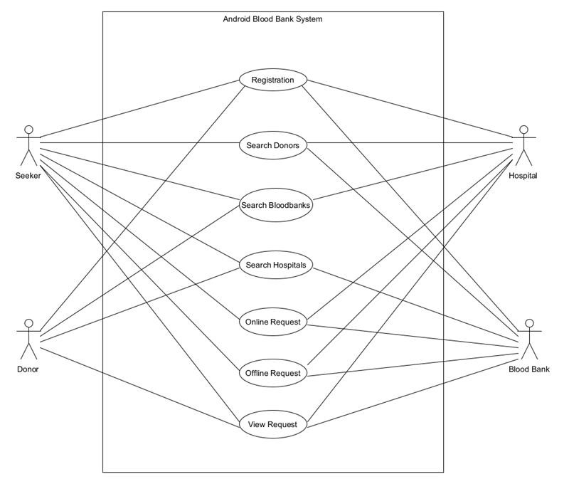

**Stakeholders’ analysis:**

There are two types of stakeholders recognized for this project's development.

• Primary Stakeholders or Positive Stakeholders: A positive stakeholder or primary stakeholder perceives the good aspects of the project and benefits from its success. These stakeholders contribute to the project management team's success.

• Secondary Stakeholders or Negative Stakeholders: A negative stakeholder or secondary stakeholder experiences the project's unfavorable consequences and may be negatively influenced by the project. This sort of stakeholder is less helpful in completing the project.

Primary Stakeholders or Positive Stakeholders:

➢Admin

➢Donor

➢ Doctor

➢ Nurse

➢ Lab technician

Secondary Stakeholders or Negative Stakeholders:

➢ Organizers

➢ Receptionist

➢ Employee

➢ Support staff

**Feasibility Analysis:**

It is the most important part of our system. Feasibility analysis helps us to know-

* Whether or not we can complete implementing the proposed system.
* The proposed system is worth implementing or not.
* How beneficial or detrimental it might be.

Technical feasibility:

1. The existing technology is very much available in this project.
2. Resources are available to use.
3. To complete the project, we have a reliable platform.
4. The platform which we are using is an open-source development platform that can develop web-based applications, mobile apps, desktop applications, etc.
5. In the future the technology gets developed, our system can be easily updated as per necessity.

Financial Feasibility:

1. In the existing platform most of the resources are free of cost, so we can develop the software at a very low cost.
2. The necessary software is already within our reach.
3. The system is feasible in all respects and hence it encourages taking up the system design.

Operational Feasibility:

1. The system is robust, so there is very little possibility of any kind of crashing and damage.
2. The platform which we are using has a lot of security scope for the software that is being developed.
3. Designed to be used by all kinds of people.
4. The customer is benefited more by this system as most of his time is saved.

**Scope and Components:**

Blood Bank Management System is a browser-based system that is designed to store, process, retrieve and analyze information concerned with the administrative and inventory management within a blood bank. Blood Bank Management System is a software application to build such a way that it should suits for all type of blood banks in future. One important future scope is availability of location-based blood bank details and extraction of location-based donor’s detail, which is very helpful to the acceptant people. All the time the network facilities cannot be use. This time donor request does not reach in proper time, this can be avoided through adding some message sending procedure this will help to find proper blood donor in time. This will provide availability of blood in time.

**Software Component:**

1. User Registration

2. User Log In

3. Dashboard

4. Accounts

5. Donor details

6. Acceptor details

7. Find a Blood group

8. Blood Bag Number

9. Number of blood donors

10. Reporting Facilities

11. Patients received transfusion

12. Transfusion Reactions

13. Date of Donation of blood

**Hardware Component:**

1. Sensor

2. Hub

3. Server

4. Computer

5. CC Camera

**Process Model:**

Agile methodology is a routine used for the development of the project which supports the respond to the volatility of building software through incremental, iterative work pace. A mobile application is developed using agile techniques. In this project, a new and productive approach which we can use to solve the problem of blood bank management using XP techniques. Just with simple touch donor will be requested to enter a person's details like name, telephone number, age, weight, date of birth, blood bunch, and address. At the time of emergency, information regarding donor can be checked using GPS nearby. Once the application is invoked, the user can enter the blood group which they require, it will show the donor details nearby and send an alarm message to the user. If the donor agrees for the request an OTP is sent for the verification process. If in case the donor rejects the request the next donor is automatically searched. Once the donor gives the blood it will remove the donor detail for next a quarter of a year.

**Effort’s Estimation:**

In our project, we can assume that SLOC is 10000. This project is semi-detached project.

Effort= PM= Coefficient <Effort Factor> * (SLOC/1000) ^P

= 3.0 * (10000/1000) ^ 1.12

= 39.55 persons-months

Development Time = DM = 2.50*(PM) ^ T

= 2.50 * (39.55) ^ 0.35

= 9.06 months

Required Number of people = ST = Effort (PM)/Development Time (DM)

= 39.55 /9.06

= 4.37~ 5 persons

**Activity Diagram:**

|  |  |  |
| --- | --- | --- |
| **Activity** | **Duration** | **Precedence** |
| A. Hardware Selection | 2 |  |
| B. Software Selection | 4 |  |
| C. Design | 3 |  |
| D. Code | 5 | B, C |
| E. Test | 3 | D |
| F. File Take On | 2 | A, B |
| G. Write User Manual | 10 |  |
| H. Install | 2 | C |

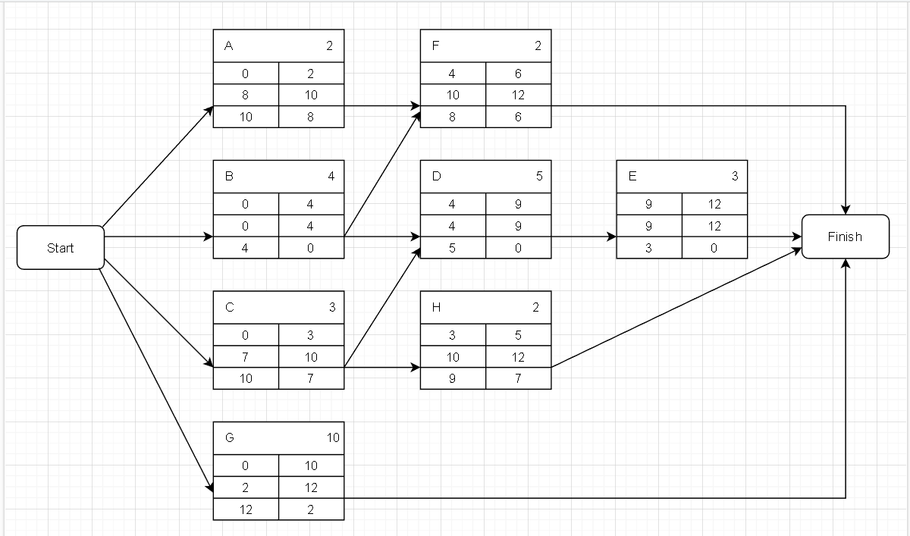

**Critical Activity Finding:**

Path 1: Start – A – F – Finish

Path 2: Start – B – F – Finish

Path 3 Start – B – D – E – Finish

Path 4: Start – C – D – E – Finish

Path 5: Start – C – H – Finish

Path 6: Start – G – Finish

Here the Path 3 is the critical activity duration.

**Risk Analysis:**

A project's risk is the potential for an unexpected occurrence to occur. A risk analysis is critical after obtaining the requirements since it helps identify potential problems that may arise during and after development of the project. There are a certain number of specific hazards that come with any undertaking. Blood Bank management systems are the focus of our research. We need to know the categories of risk in which it is necessary to identify the probable unknown occurrences of the future and their causes and consequences in order to examine the risk factors. In terms of potential danger, the following are the most significant classes:

**• Actor**: Related to stockholders of the project.

• **Technology**: Availability and performance of the technology. For example: We have to know about the availability percentages of IOT basics and automated system as we are using them to complete the project.

• **Structure**: Management structures and systems which includes affecting planning and control.

• **Task**: The common danger in here is that underestimating the amount of work required to complete the project.

Risk refers to the potential of an unknown occurrence happening in a certain situation. Under each category, there are some risk components. We must include the risk associated with our project into the risk component.

• **Risk of non-conformance:** The requirements may not be satisfied. Risk Example: While the donor

gives wrong information, it is unable to detect specific problem by scanning or sensors.

• **Cost Risk:** Our project may go over budget. Risk Example: The project may be finished on time and under budget, but user representative training may go beyond budget.

• **Support Risk:** the risk associated with system updates. Risk Example: When upgrades are required, the development team may experience turnover. The new squad will have a tough time keeping up with the old team.

• **Schedule Risk:** The risk of not delivering the product on time. Risk Example: There maybe delay in our project critical path for stuff turnover, technology problem and so on which will affect the project completion time.

The risks associated with a project are not equal. Risk varies depending on its nature. The risk might be

1. Catastrophic,

2. Critical,

3. Marginal,

4. Negligible.

Additionally, there are some odds that a certain danger may occur or the risk is certain, but we must assess the risk's consequences. Additionally, we will quantify the risk exposer, which is a quantitative way to determining the possible loss of a corporation. Risk monitoring, mitigation, and management are all terms that refer to the same procedure.

|  |  |  |  |  |  |  |
| --- | --- | --- | --- | --- | --- | --- |
| Risk  ID | Description | Risk Categories | Probability | Cost | RE | Utility policy |
| 1 | Human efforts or resource uncertainty | Development environment (DE) | 5 | 7 | 35 | Resource  certainty |
| 2 | Privacy is difficult for storing information or data | Business Impact (BU) | 5 | 10 | 50 | Data secured |
| 3 | System takes more time for  storing and updating the data. | Project size (PS) | 7 | 6 | 42 | System takes less  time and retrieving time for storing and updating the data. |
| 4 | The System cannot detect the problems more than 5 km area. | Technology to be built (TE) | 8 | 4 | 32 | System detects the problems correctly |
| 5 | Late changing on requirement. | Project size (PS) | 4 | 9 | 36 | Changing timely |
| 6 | Lack of training simple computer operations which is necessary for the users working on the system. | Development  environment (DE) | 6 | 4 | 24 | Enough trained computer operations |
| 7 | Blood delivery date may exit | Business impact (BU) | 5 | 8 | 40 | Blood delivery on time |
| 8 | Lack of donors | Project size (PS) | 3 | 7 | 21 | Have Necessary donors |
| 9 | High rate of stuff turns over | Stuff size and experience (ST) | 7 | 9 | 63 | Low rate of stuff turns over |
| 10 | Low estimation of the size | Project size (PS) | 6 | 7 | 42 | High estimation of the size |

The Probability and cost have been graded on a scale of 1 to 10. The higher the rating, the more serious the hazards; the lower the rating, the less serious the risks. The term "risk exposure" refers to the unknown commercial consequence of our undertaking. As we are done with identifying risk, we have to plan our risk. There are some steps of planning where we will decide what to do with risks.

**Risk acceptance**: There is no other ways to accept the risk rather than prevent the risk.

• Example for Project: In the system testing it may show that the software detecting the problem of the blood bank system but before publishing the problem system crashes sometimes but there is no time left to fix the problem. So, we need to accept the risk for the first release of our project and will try to develop it in another updated release.

**Risk avoidance**: Avoiding the activity which could bring risk.

• **Example for Project**: We are considering 15 developers are working in a team to build the project. One of the experienced team members could have got some problem and failed to complete the critical path activity in time. But involving another member who is eligible to handle the same work we could involve him with the project from the starting period by maintain same or moderately high employee cost.

**Risk Reduction**: The actions to reduce a particular risk.

• **Example for Project**: We have discussed a risk about the system crash in the risk acceptance steps. We could have developed a way which will save the data of unseen result so that the system doesn’t need to take the data from the very first even though crashing the system.

**Risk transfer**: Transferring the risk prevention responsibilities to another team or organization.

• **Example for our Project**: We have identified the risk that our system will not sense the detail information about the donor and the consumer or patient if the area is greater than 5 km and our developers may supposed to fail to solve the problem. So, we can transfer the risk prevention responsibilities to other organization in a basis of contract.

**Risk Mitigation**: Trying to reduce the post impact of a risk.

• **Example for our Project**: We could have the high rating of stuff turn over and, in this situation, we can hire some excellent fresh graduates with enough salaries until the project completion time. Sometimes there is a confusion among the whole team about the risk prevention or acceptance. To solve this confusion there is a term called “Risk Reduction Leverage”. We're making the assumption that rural communities have suddenly become more interested in our system.

We can save 0.5 percent of this loss by paying 8,000 taka to teach some individuals for remote regions, but there are no end-user trainers, thus there is a 1% possibility of losses of 50,000 taka. We'll appreciate the RRL's value if it costs more than one

RRL= REbefore – REafter/ Risk reduction cost

= (1% of 50000) – (0.5% of 50000)/8000

= 0.06

As the RRL< 1 so the step is not worth of doing. These are the possible risks and prevention for our Blood bank management project.

**Budget:**

|  |  |
| --- | --- |
| Laboratory Supplies | 4,00,000 |
| Overhead and Amortization | 50,000 |
| Labor | 2,50,000 |
| Distribution | 1,00,000 |
| National Administrative and Research Program | 3,00,000 |
| Recruitment, Canteen and Mobile unit operation | 2,00,000 |
| Total | 13,00,000 |

**Conclusion:**

This proposed Blood Bank Management System provides a reliable platform for both donors and acceptors. The Blood Bank Management System is a web-based application helps to reduces human error and issues with data redundancy. It is a quick and effective way to communicate without any security threats as the data entered will be regularly updated and verified thereby increasing the probability of saving one's life. Moreover, it is made more accessible by the availability of a location-based system that allows one to use Google maps to find the closest blood bank.